*EXPERIMENT* – Ultrasonic Sensor (Obstacle detector and distance measurement)

*Circuit Diagram*

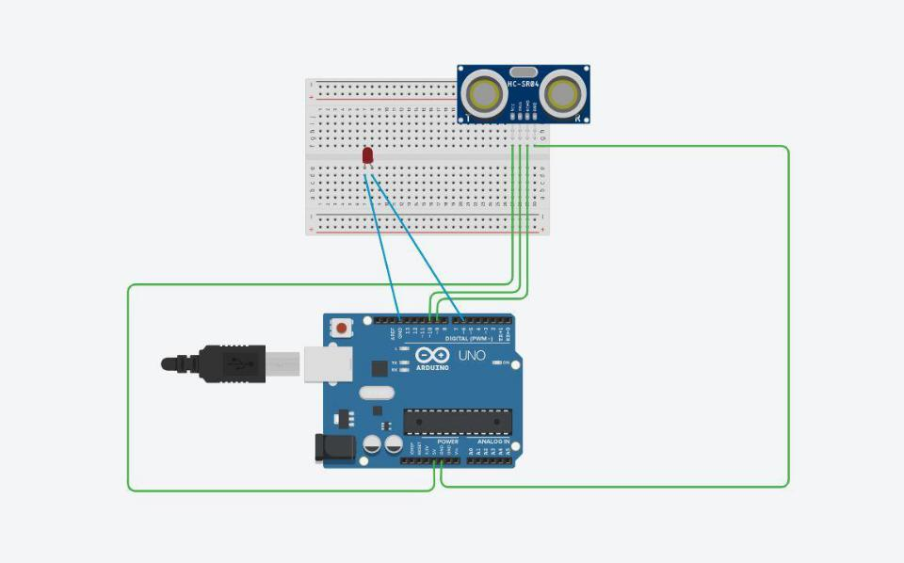

*Theory*

*Concept used:*

Various concepts are used in this exp as listed:

1. Ultra Sonic Sensor.
2. Combination of Ultra sonic sensor with the led.
3. Code used to run Ultra sonic sensor with the help of Arduino UNO.
4. Dual behaviour of digital pins of Arduino UNO board.

*Learning and Observation:*

In this exp we learnt about :

1. We learnt about Ultra Sonic Sensor.
2. We learnt about the pulseIn command of Arduino.
3. We learnt about the transmitter and receiver pins of the Ultra Sonic Sensor.

*Observations:*

1. We give delay time in microseconds.
2. If the distance of the object is less than 20 than led should glow with noticeable effect.

3. By using the analog command for output we use numeric value instead of LOW and HIGH.

*Problems and Troubleshooting:*

1. The cable is not connected properly with the system.
2. Led glow without noticeable effect.
3. Change the connecting cable of Arduino and system.
4. Delay is in microseconds.

*Precautions:*

1. In void setup, all pin mode should be declared.
2. Loop doesn’t go infinite times.
3. While using LED with Ultra Sonic Sensor, the LED should be connected to the analog pin.

*Learning Outcomes:*

1. Writing basic code used for glowing LED with the help of Ultra Sonic Sensor.
2. Applications of analog pin.
3. Applications of Ultra Sonic Sensor.
4. Glowing Effect of LED.